**Shri G. S. Institute of Technology & Science, Indore,Department of Computer Engineering**



**Subject: Information and Network Security**

**Session: December – May 2021**

**Lab Assignment**

**Submitted To: Submitted By:**

**Veerendra Shrivastava Shikhar Mahajan**

**Soma Saha 0801CS171077**

**Q1. Visit to the website https://threatmap.checkpoint.com/ and answer the following**

**Questions:**

**I. How many numbers of attacks are performed in all over the world when you visit this website? Attach the screenshot.**

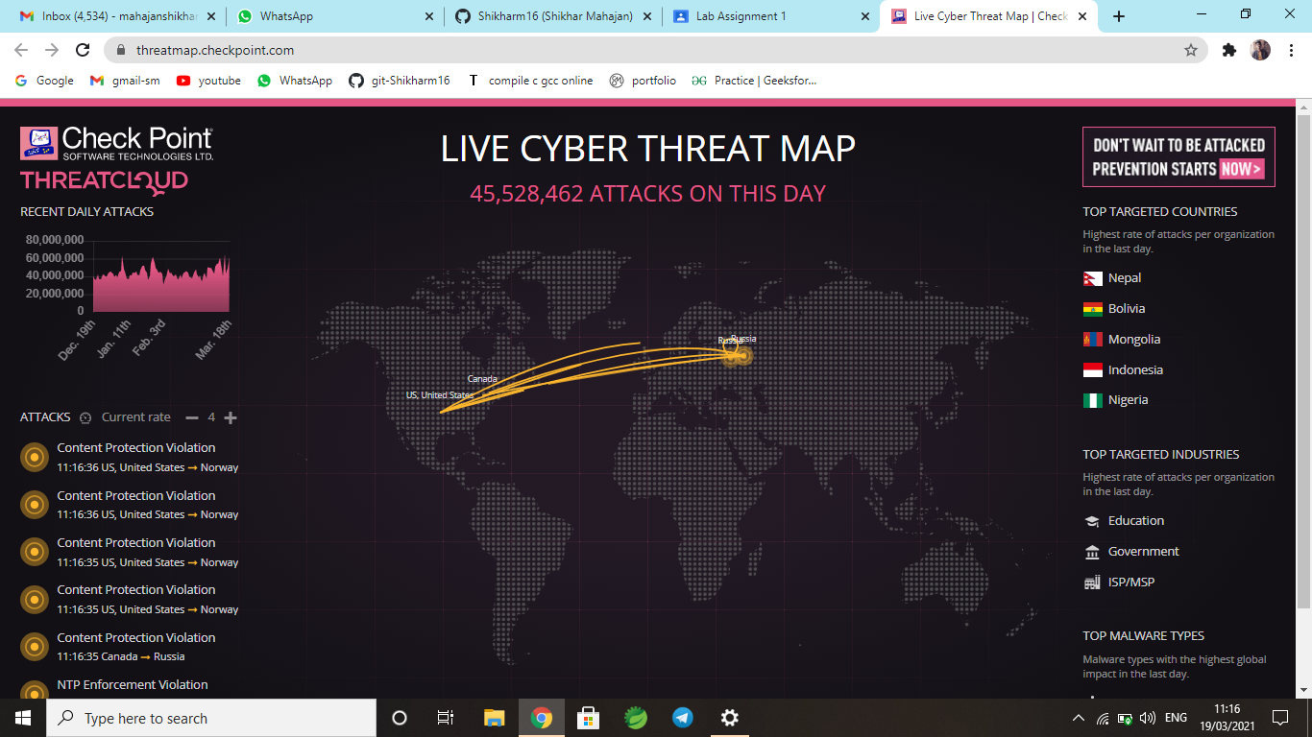

**II. Write the various malware type trends in India in last 30 Days with percentage of**

**affected organization?**

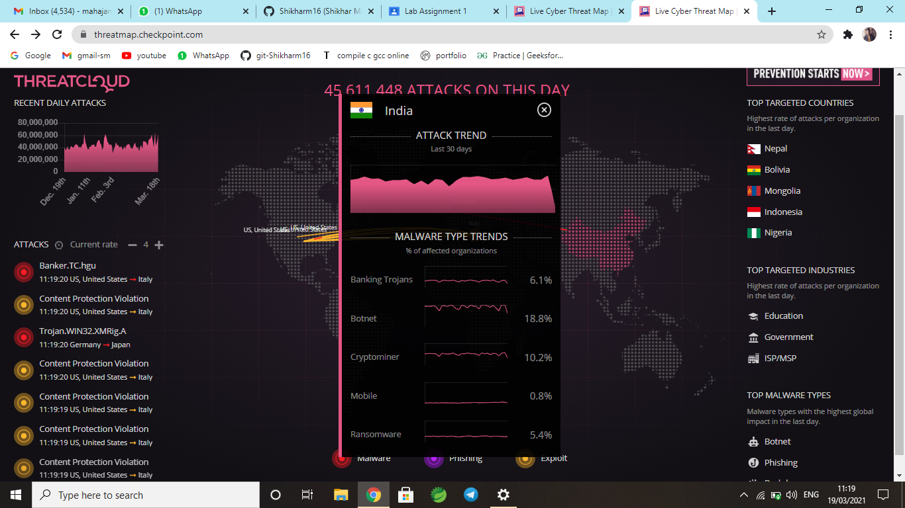

**III. Explain the working of a threat cloud map?**

A cyber threat map, also known as a cyber attack map, is a real-time map of the computer security attacks that are going on at any given time. One of the most famous was released by the company Norse and went so viral, even among non-hackers, that it got [its own story in Newsweek](https://www.newsweek.com/real-time-cyber-attack-map-shows-scope-global-cyber-war-352886) in 2015.

The map itself looks like a global game of laser tag. Beams of light, represented by different colors, shoot across a darkened screen showing where an attack comes from and where it is going. When it first caught the public eye, captivated audiences watched hackers wage cyber-war across hundreds and thousands of miles.

**How Does A Cyber Threat Map Work?**

If cyber attacks are sneaky mice – or, more appropriately, giant rats – then cyber attack maps work like the mousetrap.

Norse, for example, maintained [a global threat intelligence network](http://www.norse-corp.com/) of more than 8 million sensors and “honeypots” in 47 countries across the world. These tools impersonated thousands of applications and devices that are common targets of hackers.

When a hacker hits a Norse sensor, the hacker believes that it has breached a system. Instead, Norse collected information about the hacker’s toolkit, including his or her IP address. This information then manifested as data on the cyber attack map.

This model has continued past the demise of Norse to power live maps like Cyberthreat, ThreatCloud, and Fortinet. Some companies claim that these are real-time cyber attacks, but most are more like [selections of recent attacks](https://www.cso.com.au/article/626271/8-top-cyber-attack-maps-how-use-them/).

**IV. Write the name of any five websites which is similar to the thread cloud and attach their screenshots.**

***Websites similar to ThreatCloud are:***

• CyberThreat by Kaspersky

• FireEye

• Fortinet

• Imperva

• Bitdefender

• SonicWall

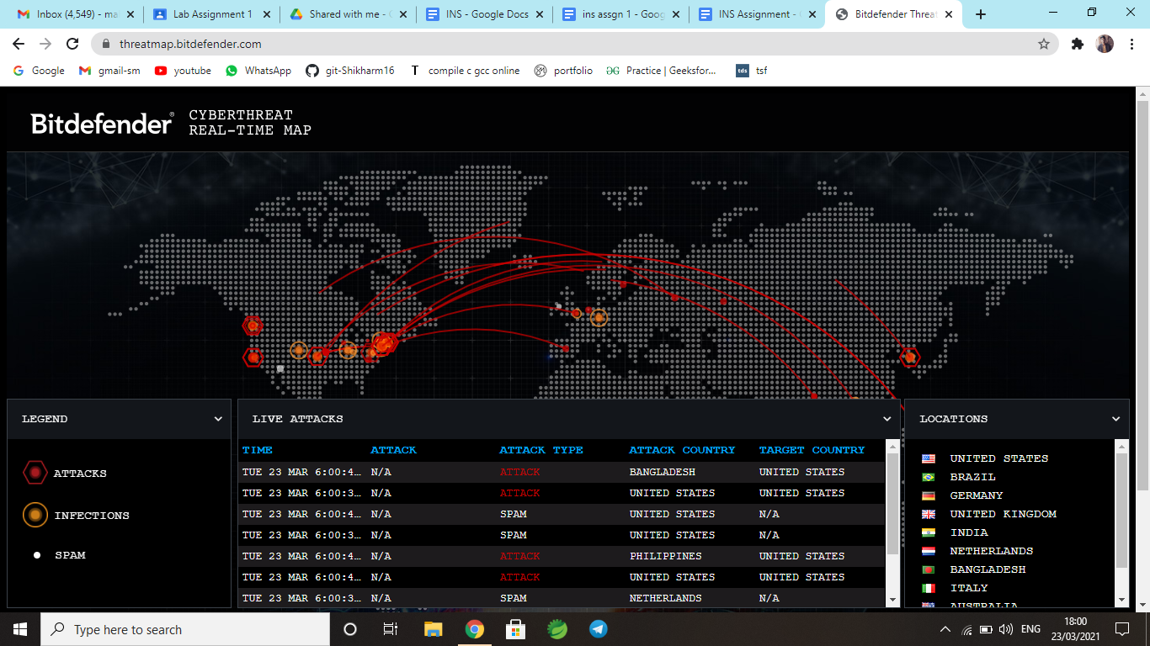

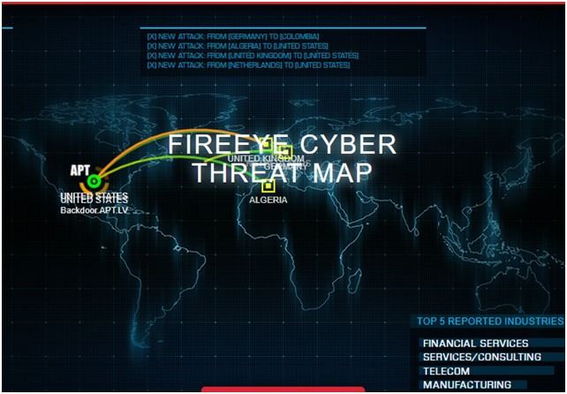

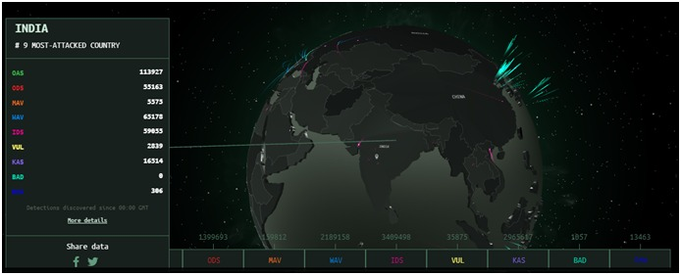

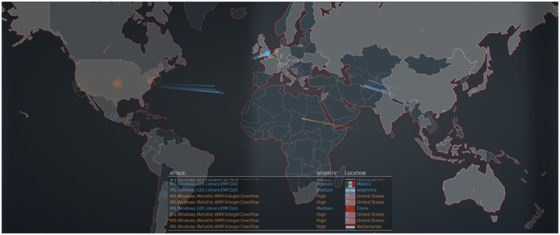

**Q2. Visit to the website https://web.archive.org/ and perform the following operation on the**

**target website i.e. www.sgsits.ac.in -**

**I. Search the target website on the wayback machine and count the number of captures with duration. Also attach the screenshot of your result.**

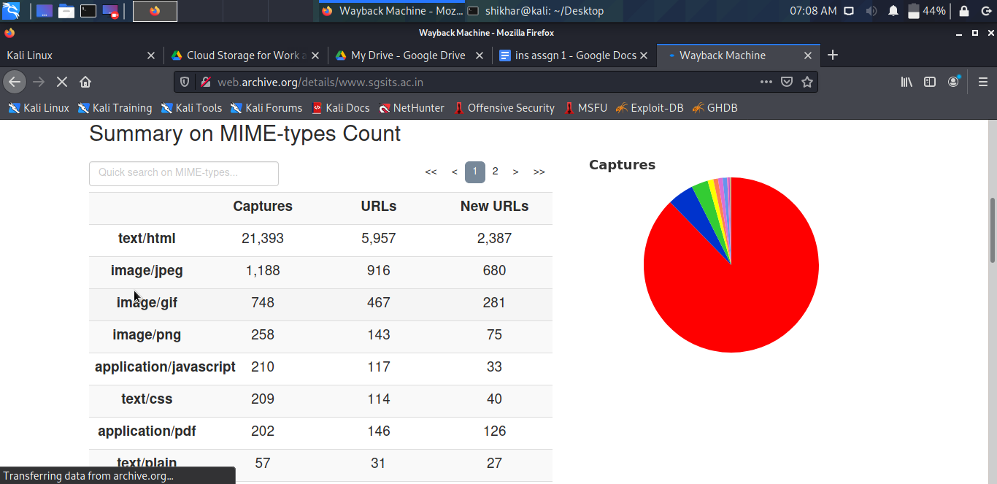

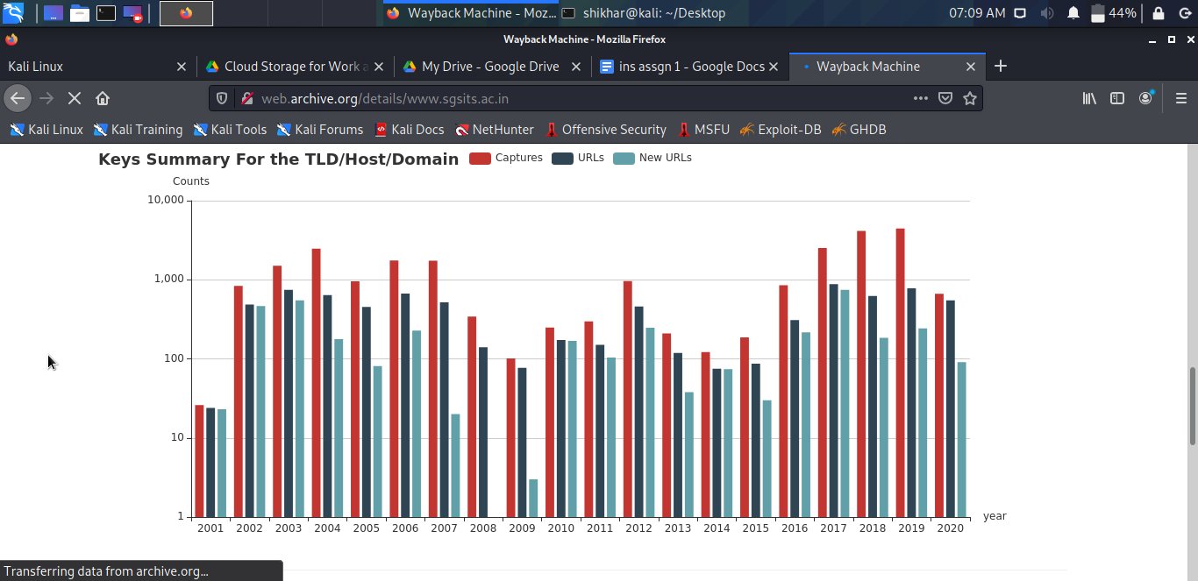

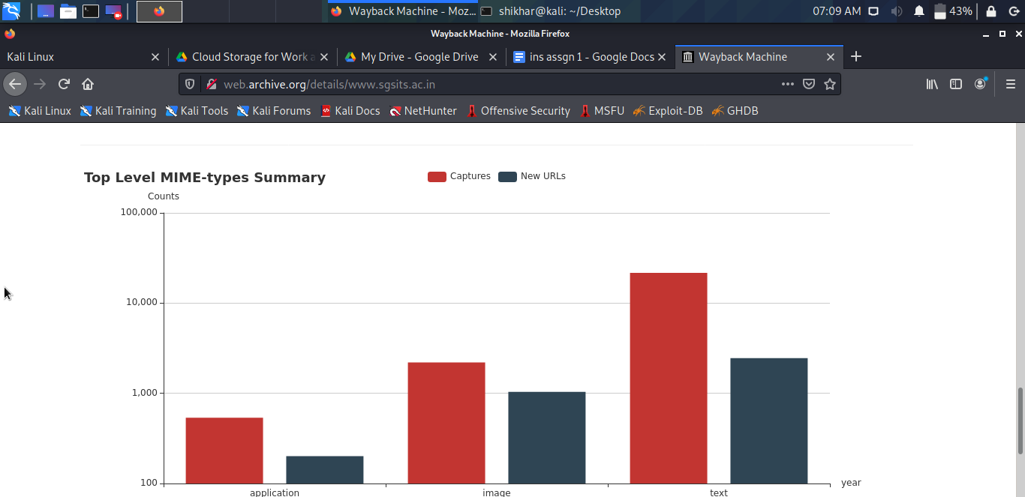

**II. Try the following filters on the wayback machine for checking the vulnerabilities in the target website:?, ?id=, .zip, readme.php, readme.txt, .csv, password, /admin/, .js, /api/, .config, msg= etc. Also attach the screenshot for each filter and/or your result.**

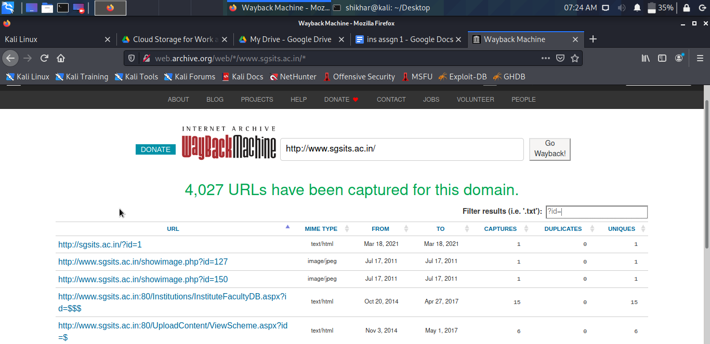

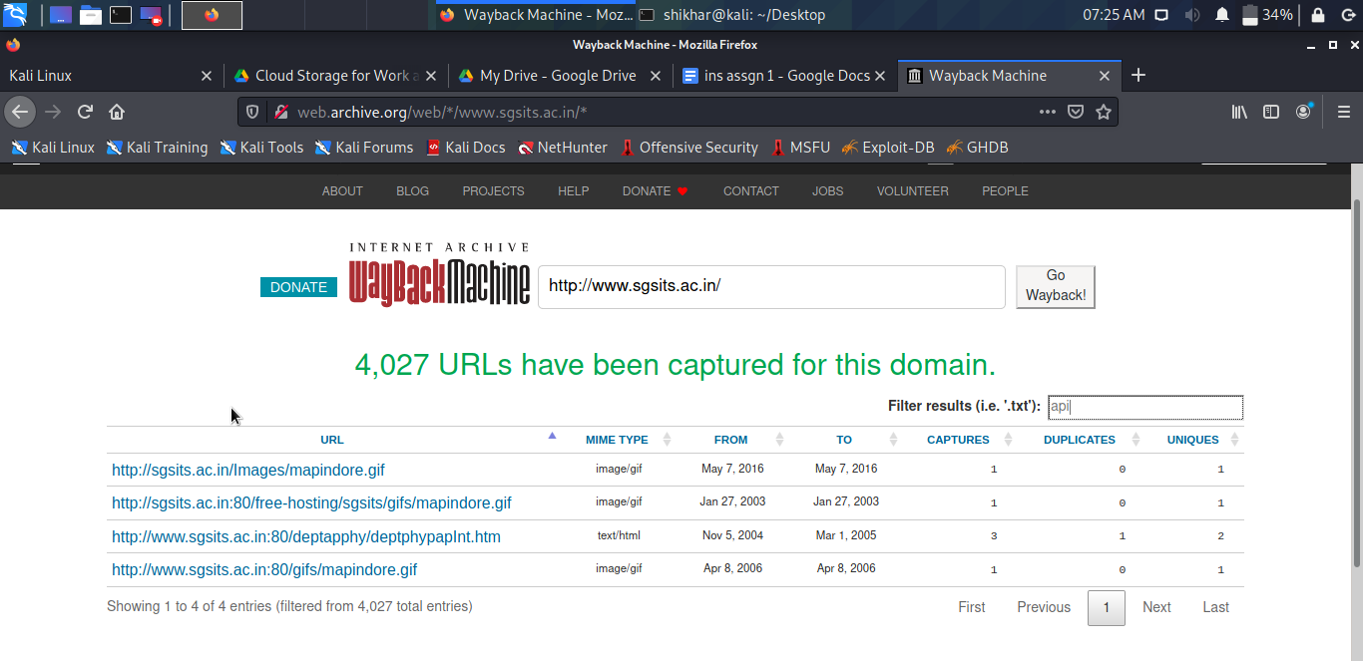

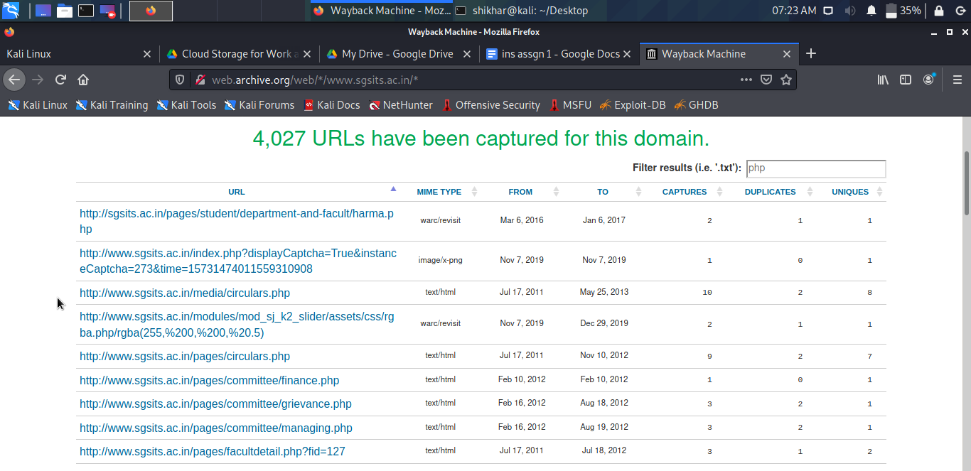

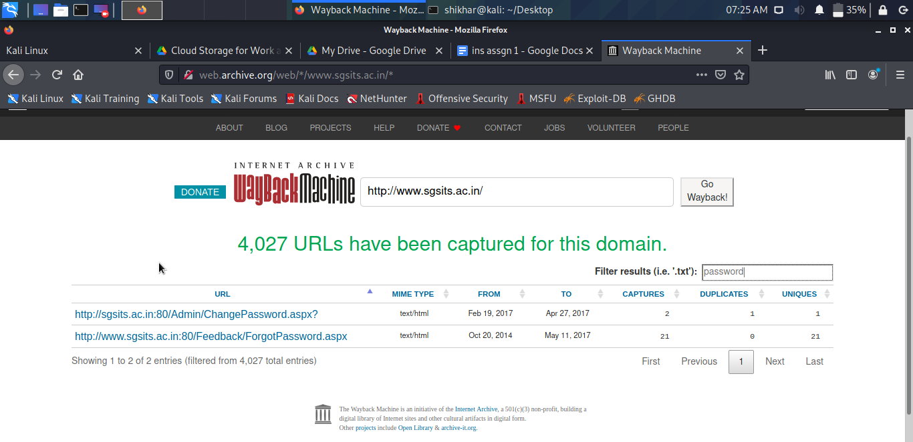

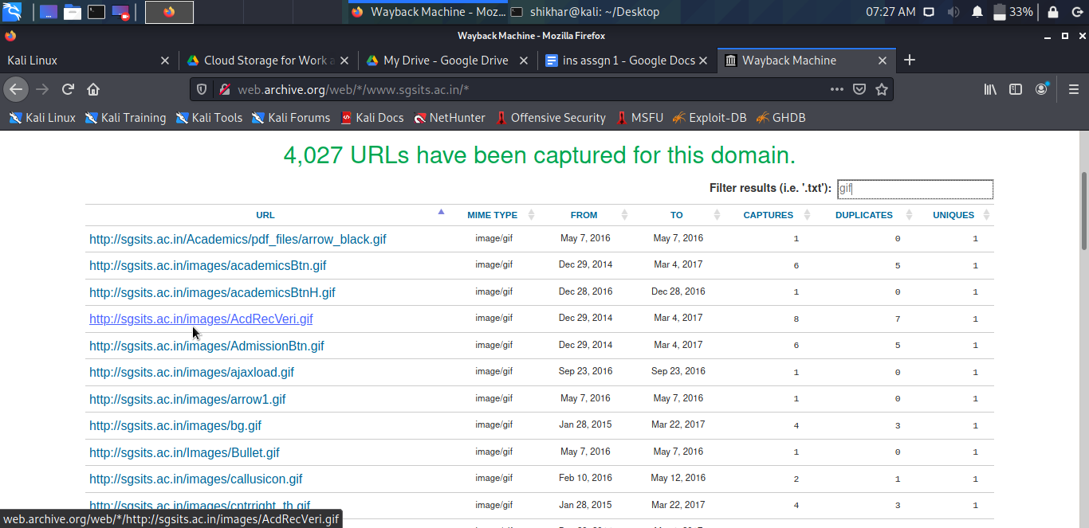

**Q3. Visit to the website https://www.netcraft.com and perform the following operation on the target website: www.sgsits.ac.in –**

**I. Write the names of various domains associated with the target website.**

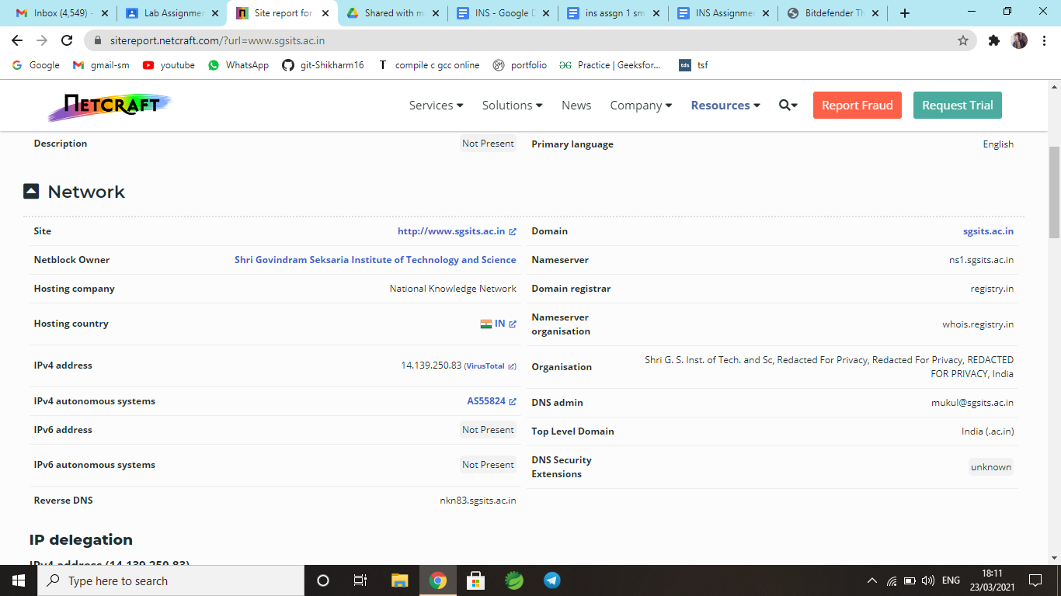

**II. Write the IP version 4 and version 4 ranges associated with the target website.**

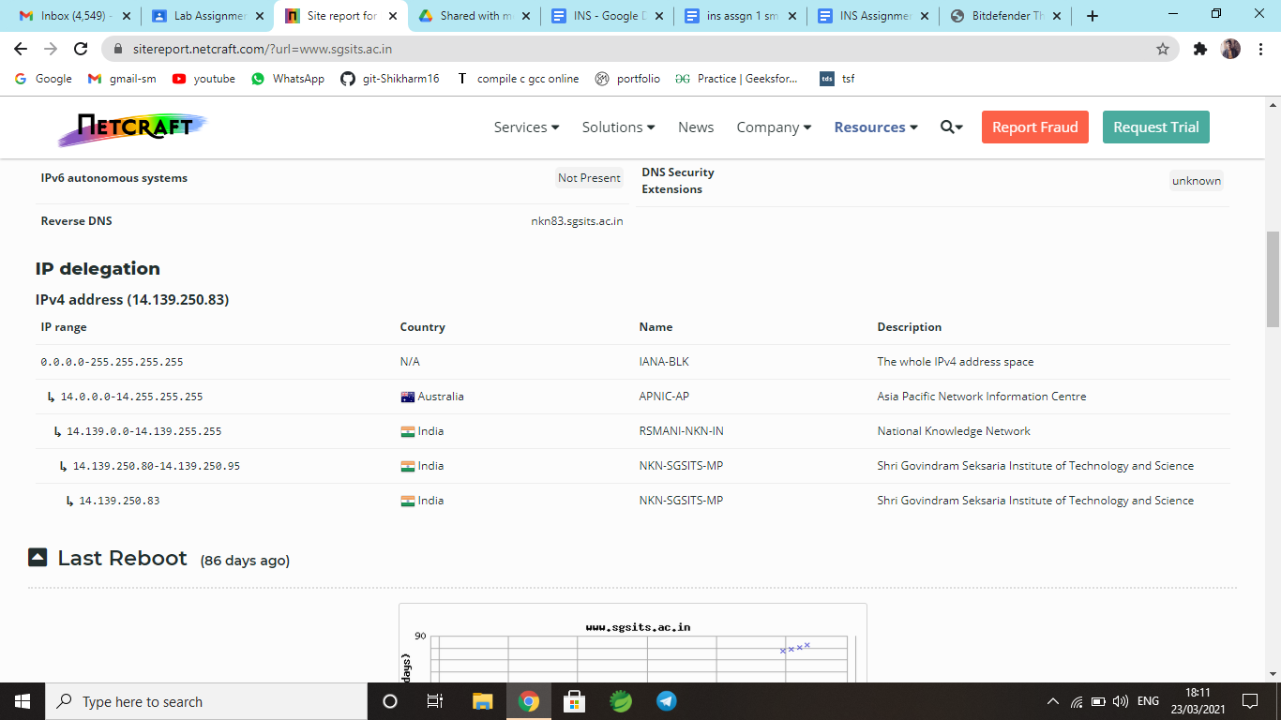

**III. What is the name and location of the server of the target website?**

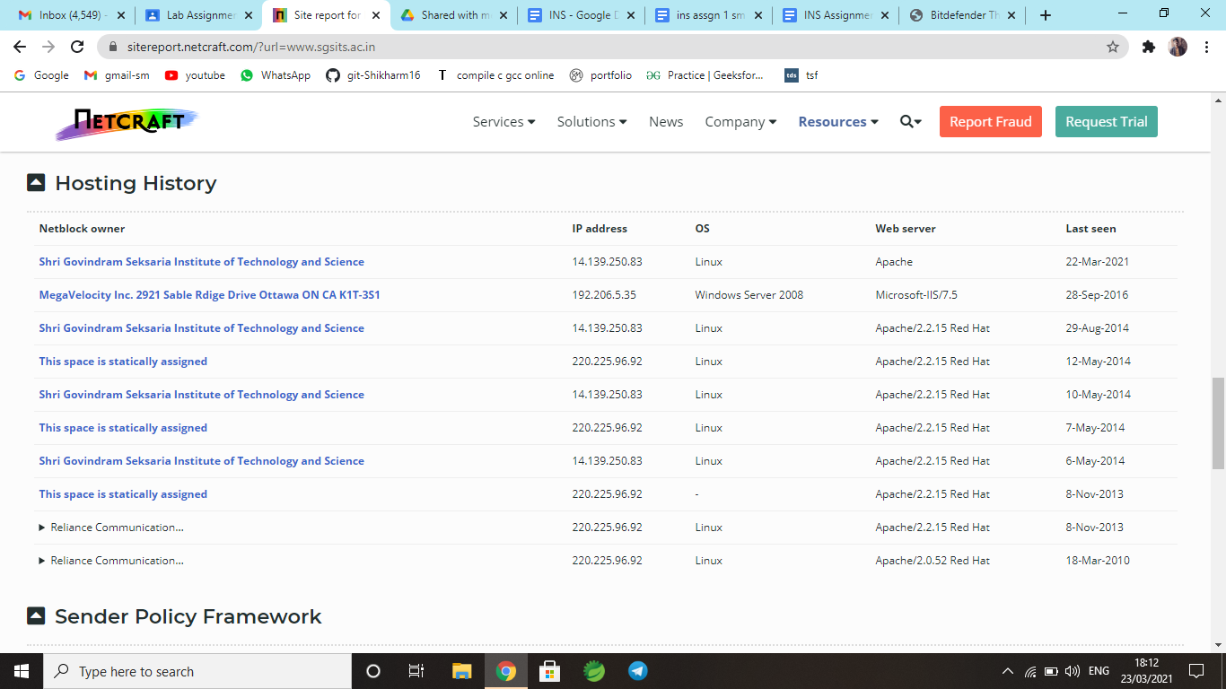

**IV. Can you detect the OS name? if yes then also write the name of the OS.**



**Q4. Visit to the website https://builtwith.com and perform the following operation on the**

**target website: www.sgsits.ac.in –**

**I. Write the name of various technologies used in designing the target website.**

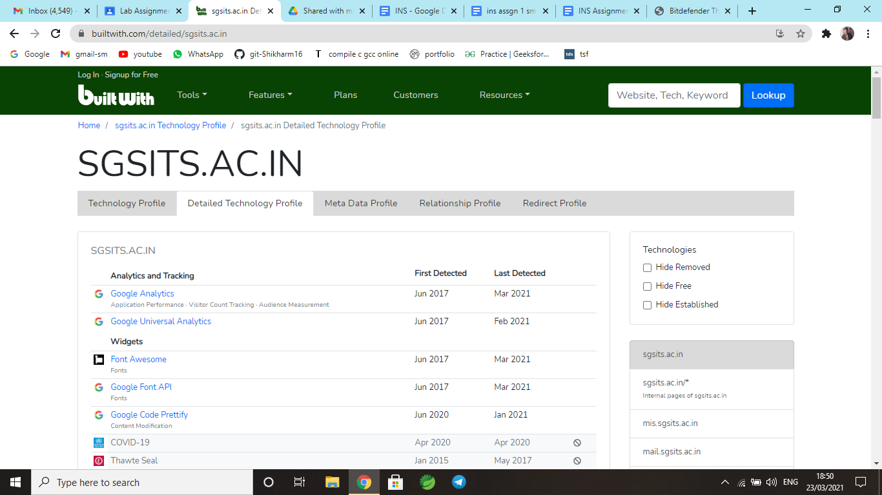

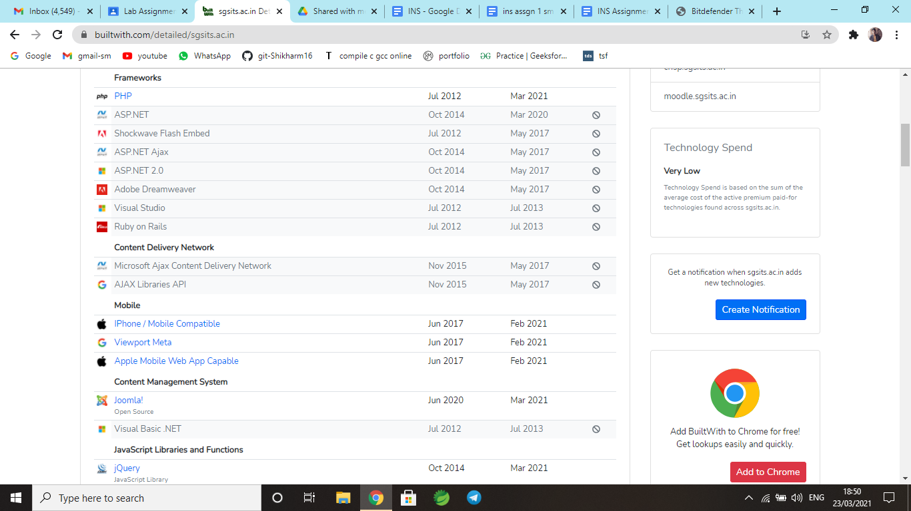

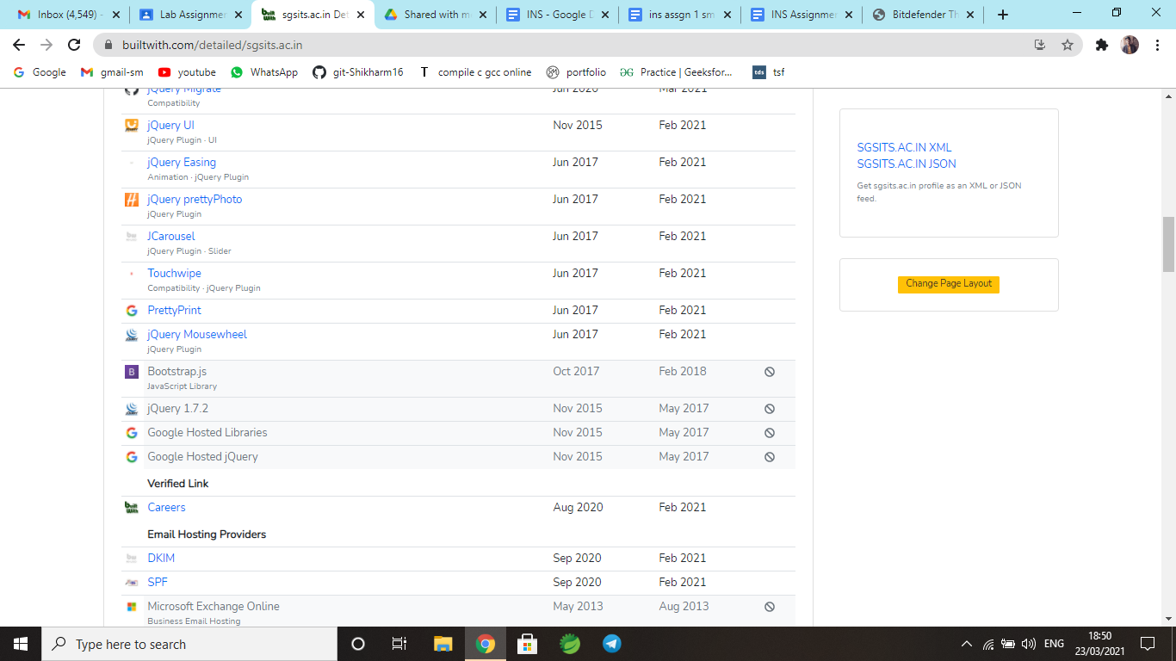

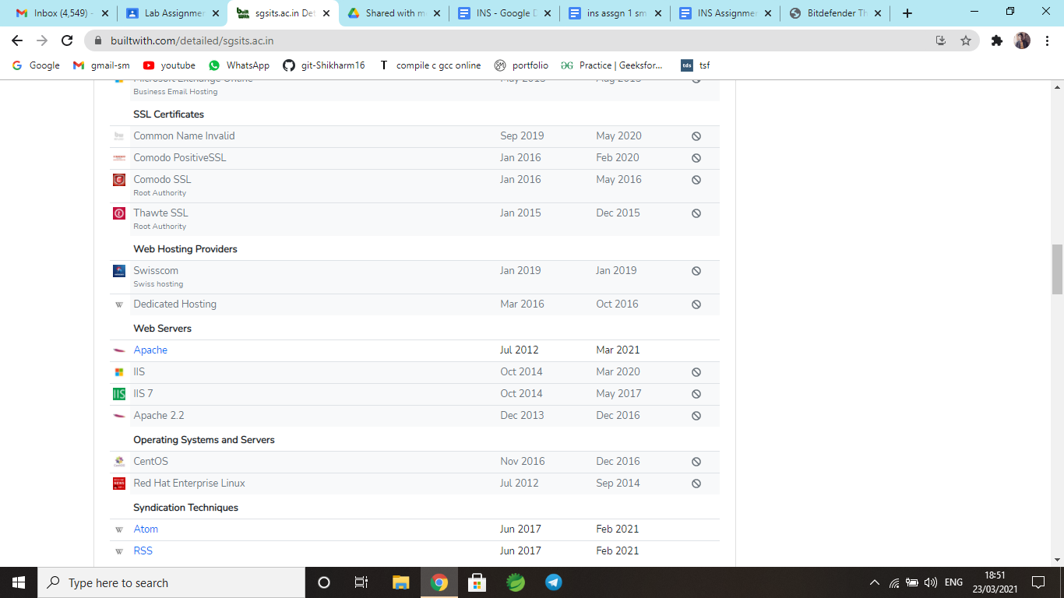

**II. Write the name of CMS used for designing the target website.**

****[Joomla!](https://trends.builtwith.com/cms/Joomla!)

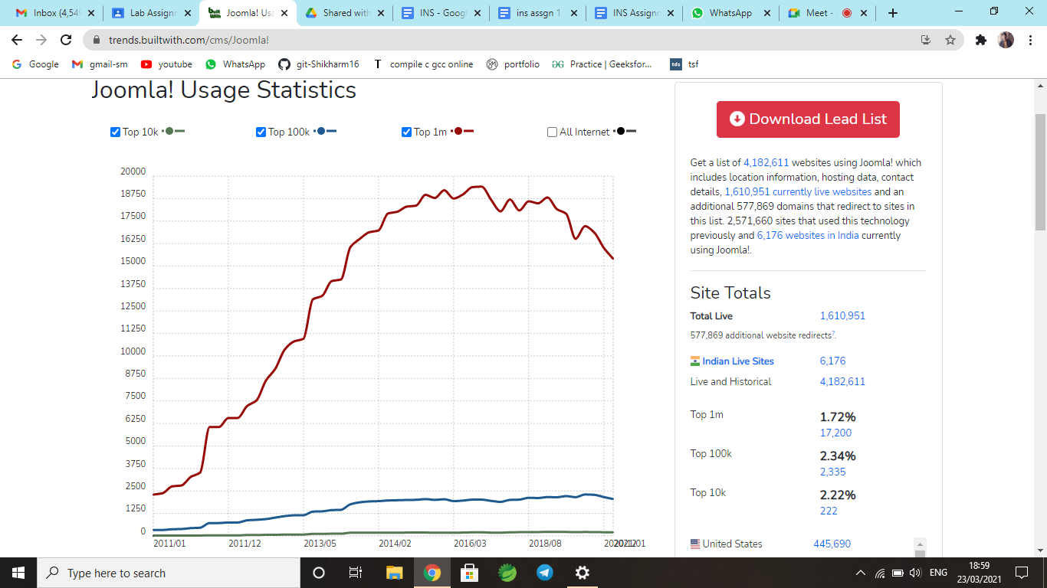

**III. Write the description about the security certificates used in the target website.**

[Common Name Invalid](https://trends.builtwith.com/ssl/Common-Name-Invalid)

[Comodo PositiveSSL](https://trends.builtwith.com/ssl/Comodo-PositiveSSL)

[Comodo SSL](https://trends.builtwith.com/ssl/Comodo-SSL)

[Thawte SSL](https://trends.builtwith.com/ssl/Thawte-SSL)

**IV. Write the name of other websites or tools which can be used for website technology**

**lookup.**

Top Alternatives to BuiltWith

* ZoomInfo.
* Leadfeeder.
* D&B Hoovers.
* Lusha.
* Lead411.
* Oceanos.
* VisitorTrack.
* Leadinfo.

**Q5. Perform the following operations:**

**I. Setup the following virtual machine in VirtualBox or VmWare environment:**

**1) Kali Linux**

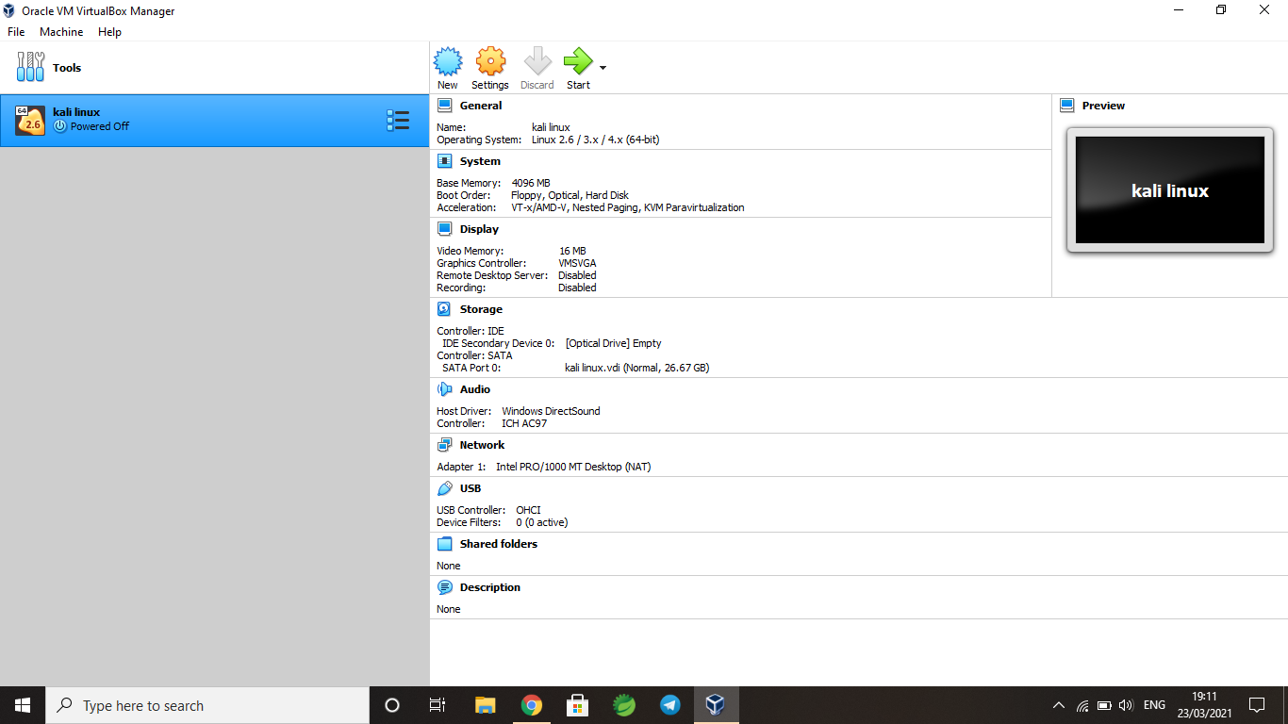

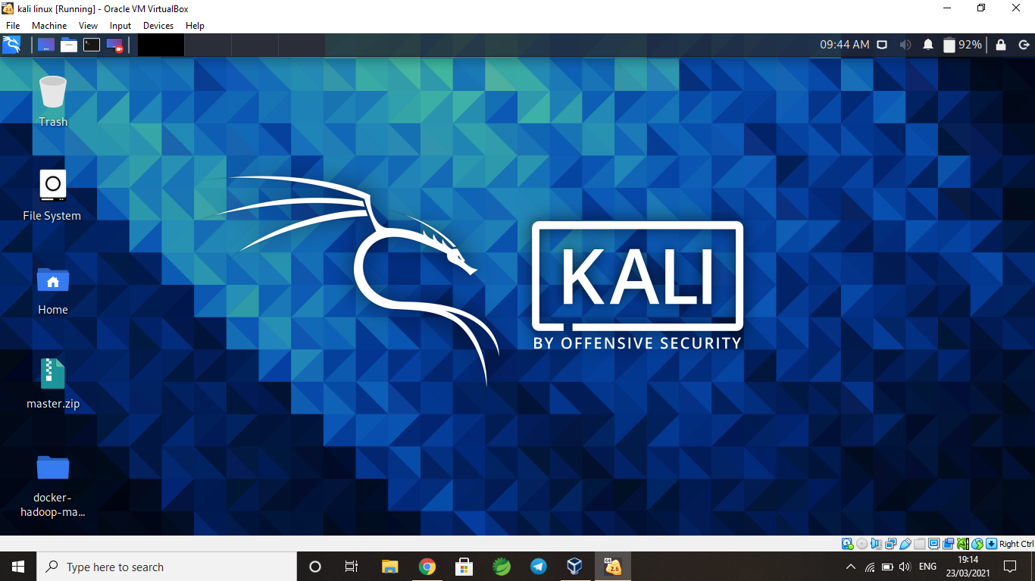

**2) Metasploitable 2**

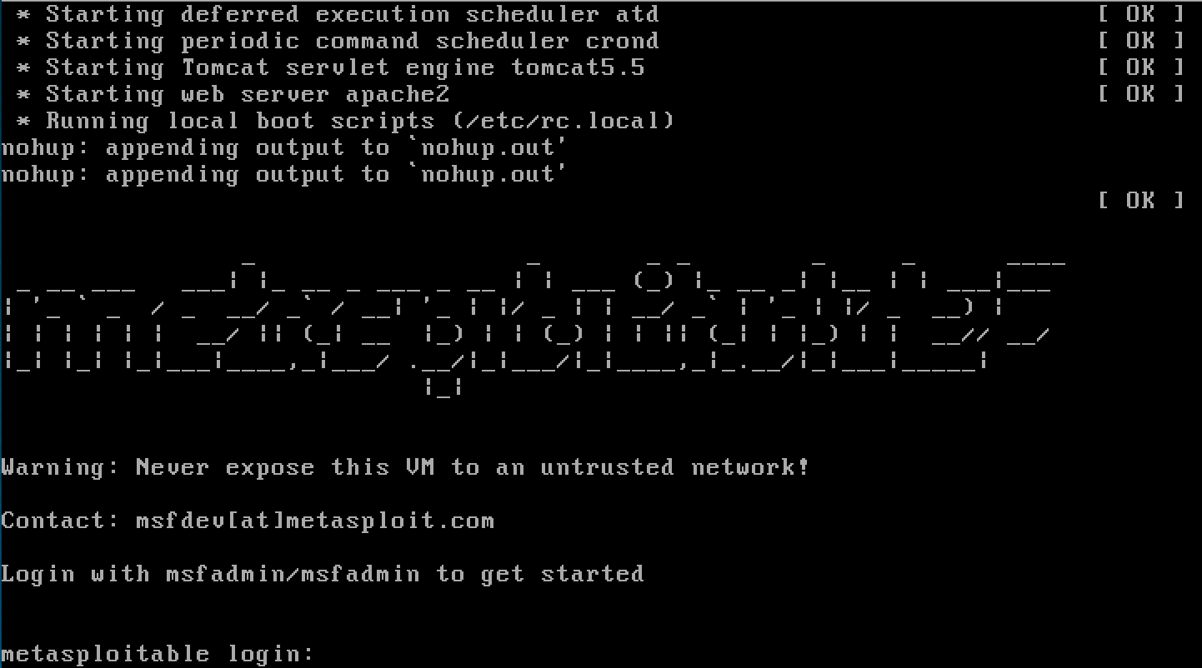

**3) Windows 7**

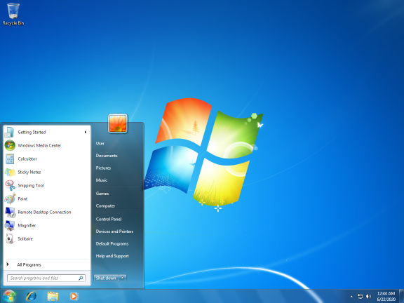

**Q6. Execute the following commands on/in the virtual machine:**

**I. Run the ifconfig in each of the virtual machine and write the IP, MAC**

**and subnet mask details.**

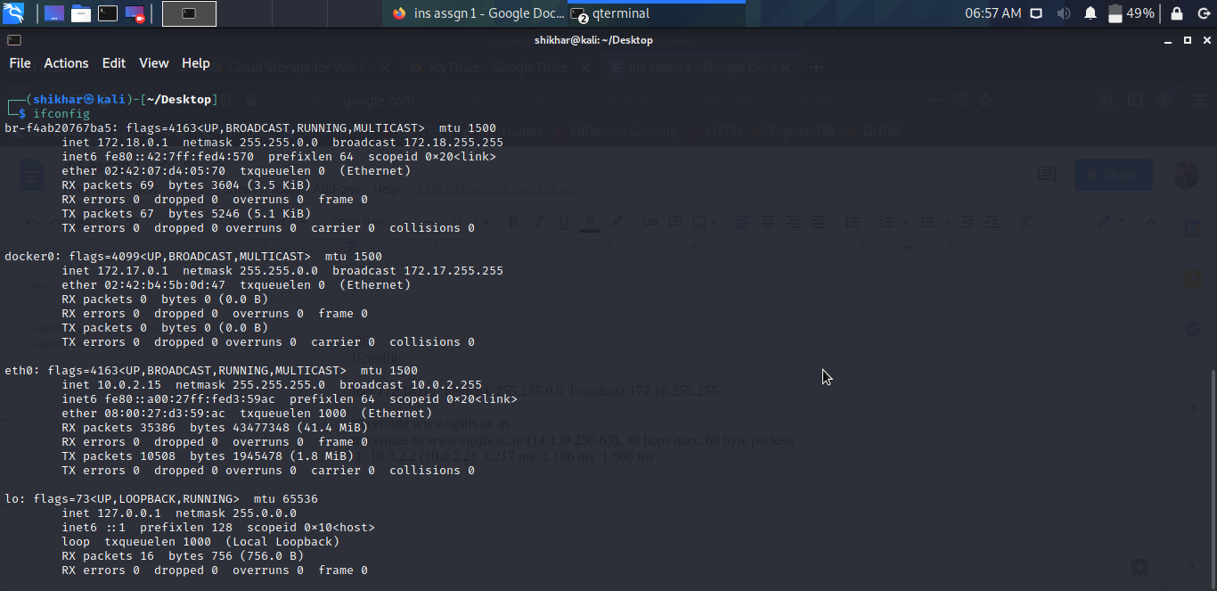

**II. Run the ping command in each of the virtual machines and ping to each other.**

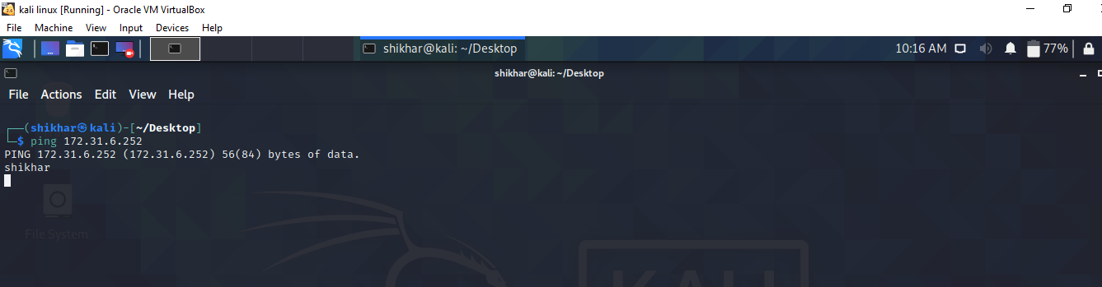

**III. Run the traceroute command from one virtual machine to another virtual machine’s IP**

**and give the explanation of the output.**

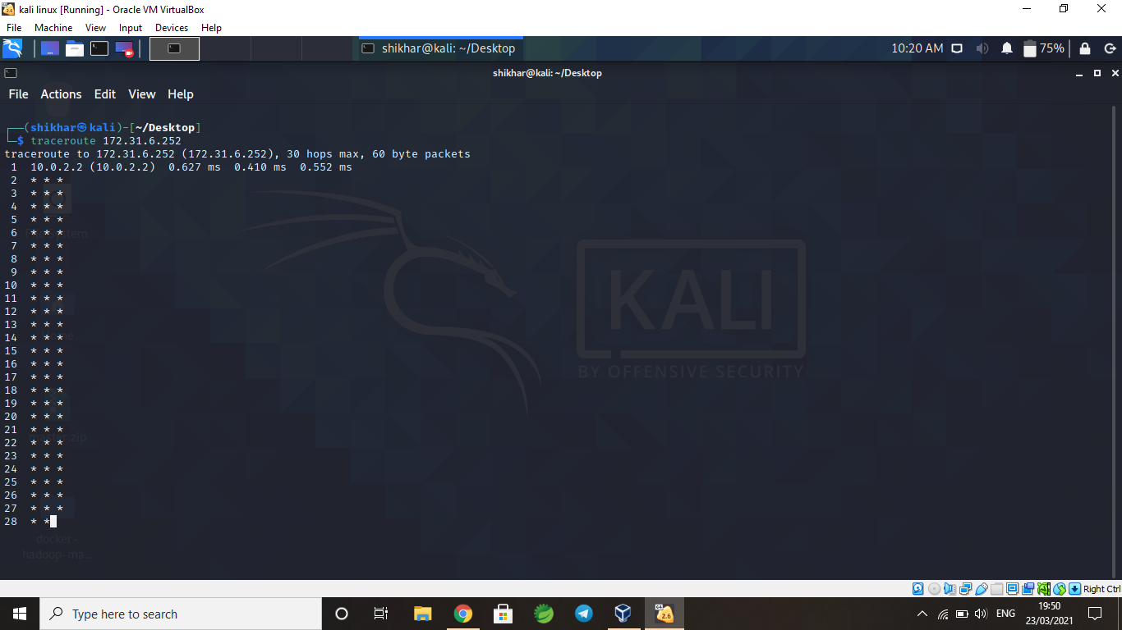

**IV. Run the traceroute command for the target website i.e. www.sgsits.ac.in and give the**

**explanation of the output.**

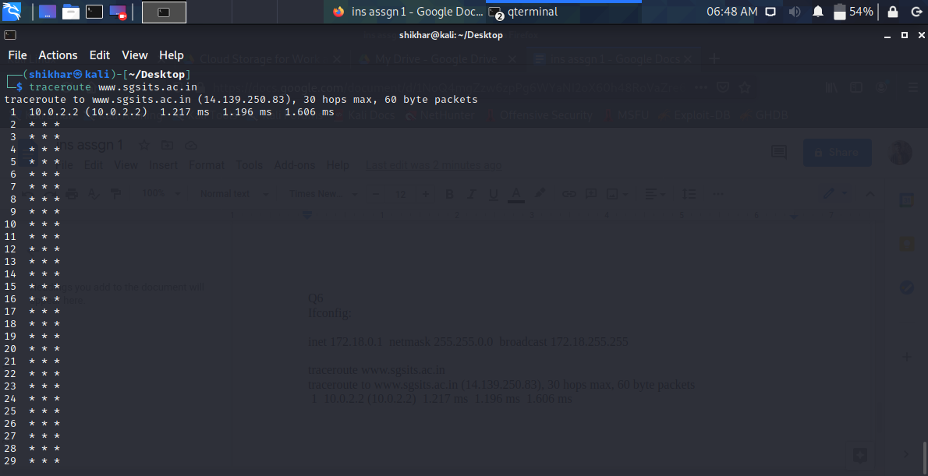

**V. Run the nslookup on the target website i.e. www.sgsits.ac.in and write the name/IP of**

**the server, mail server, IP address of the target website etc.**

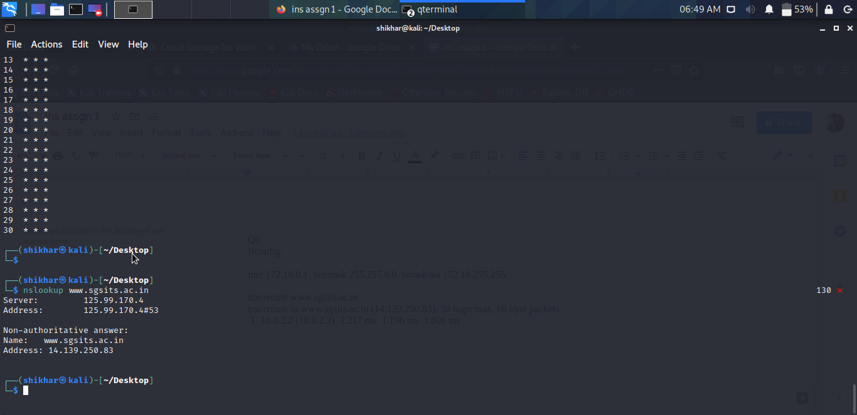

**VI. Run the dig on the target website i.e. www.sgsits.ac.in and give the explanation of the**

**output. Execute the dig command to get the name of the name servers and mail servers**

**etc.**

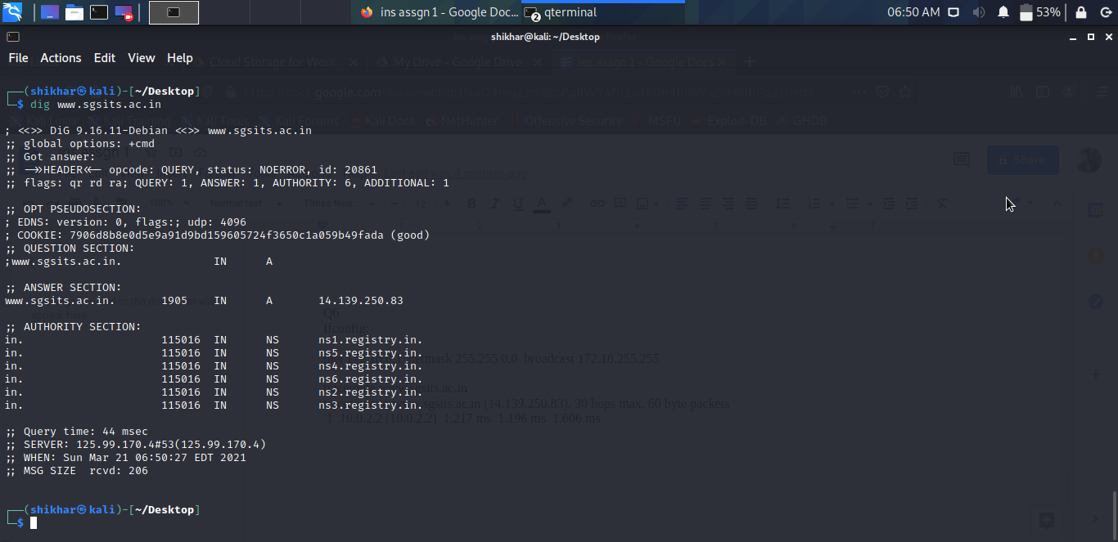

**VII. Run the netstat command and print the routing table of each of the virtual Machine.**

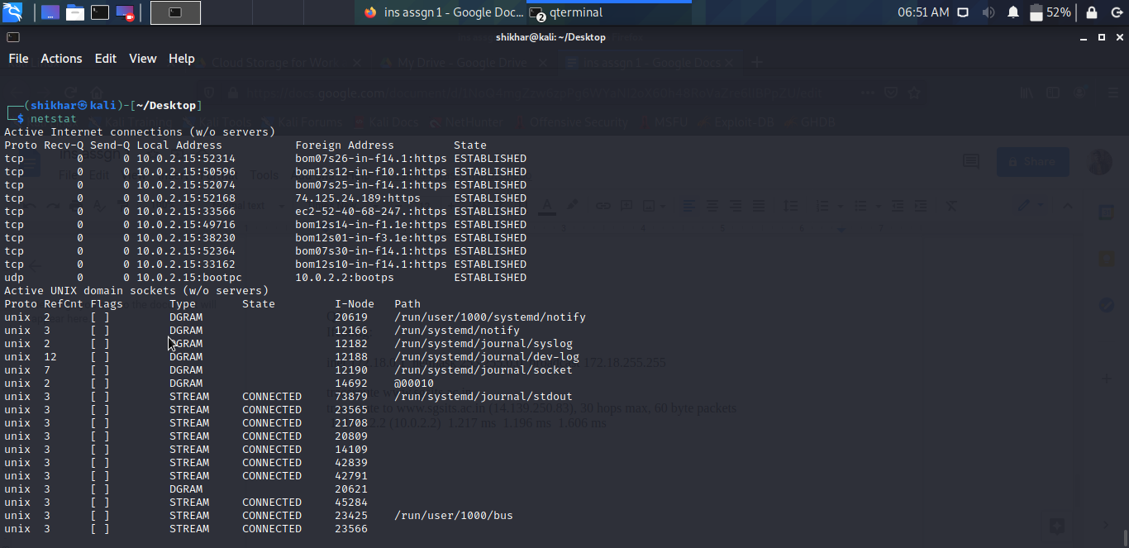

**VIII. Run the arp command and give the explanation of the output.**

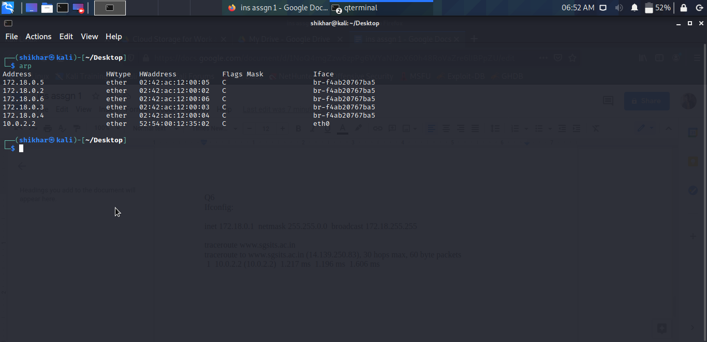

**Q7. Execute the nmap command and answer the following questions:**

**I. Execute the nmap on both the target machine i.e. windows & metasploitable 2 and give**

**the explanation of the output.**

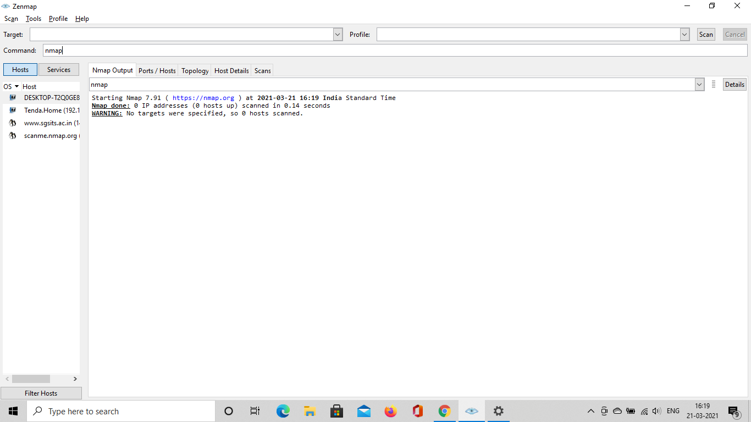

**II. Execute the nmap on target website i.e. www.sgsits.ac.in and give the explanation of the**

**Output.**

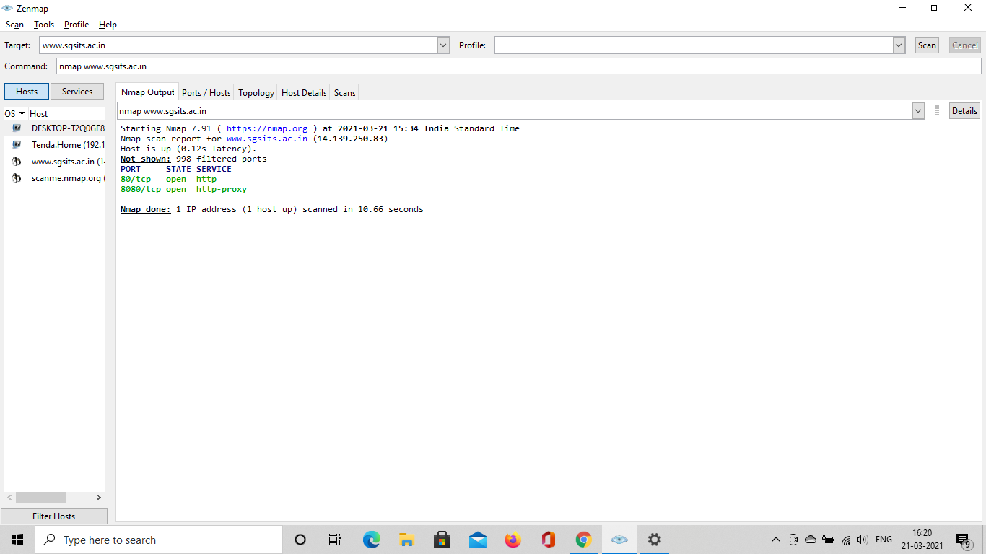

**III. Execute the nmap on both the target machine i.e. windows & metasploitable 2 and**

**display the open port in detail.**

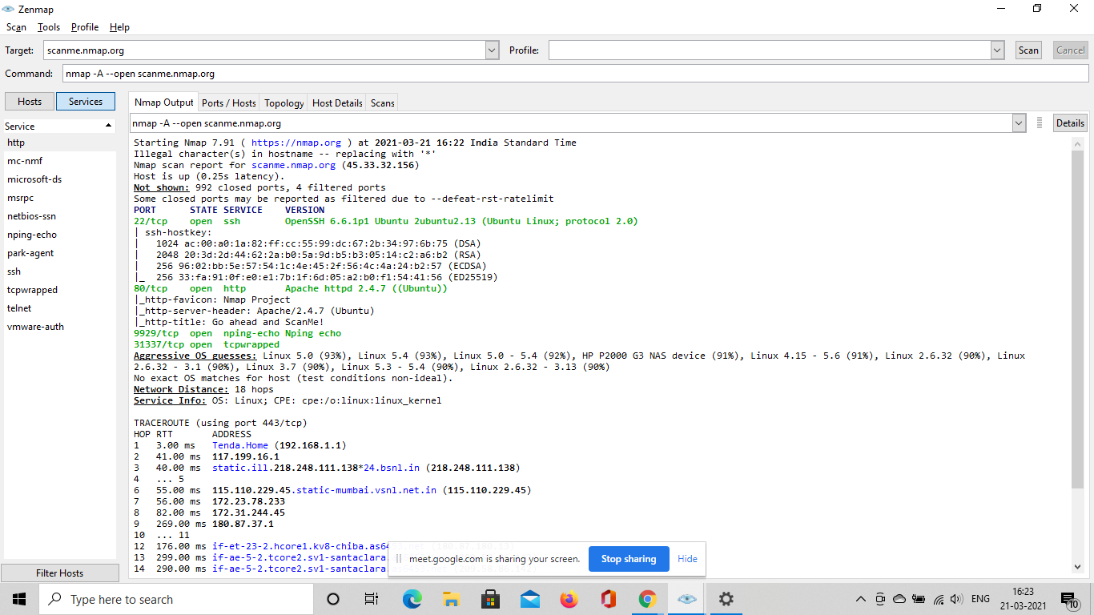

**IV. Execute the nmap on both the target machine i.e. windows & metasploitable 2 and**

**display the OS.**

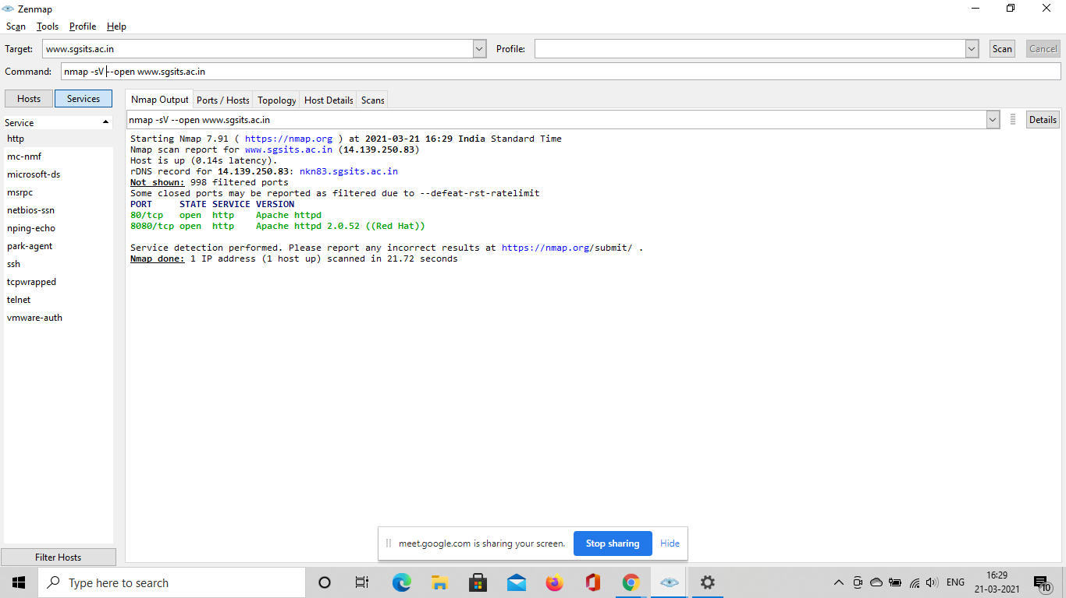

**V. Execute the nmap on both the target machine i.e. windows & metasploitable 2 and display the services running on various open ports.**



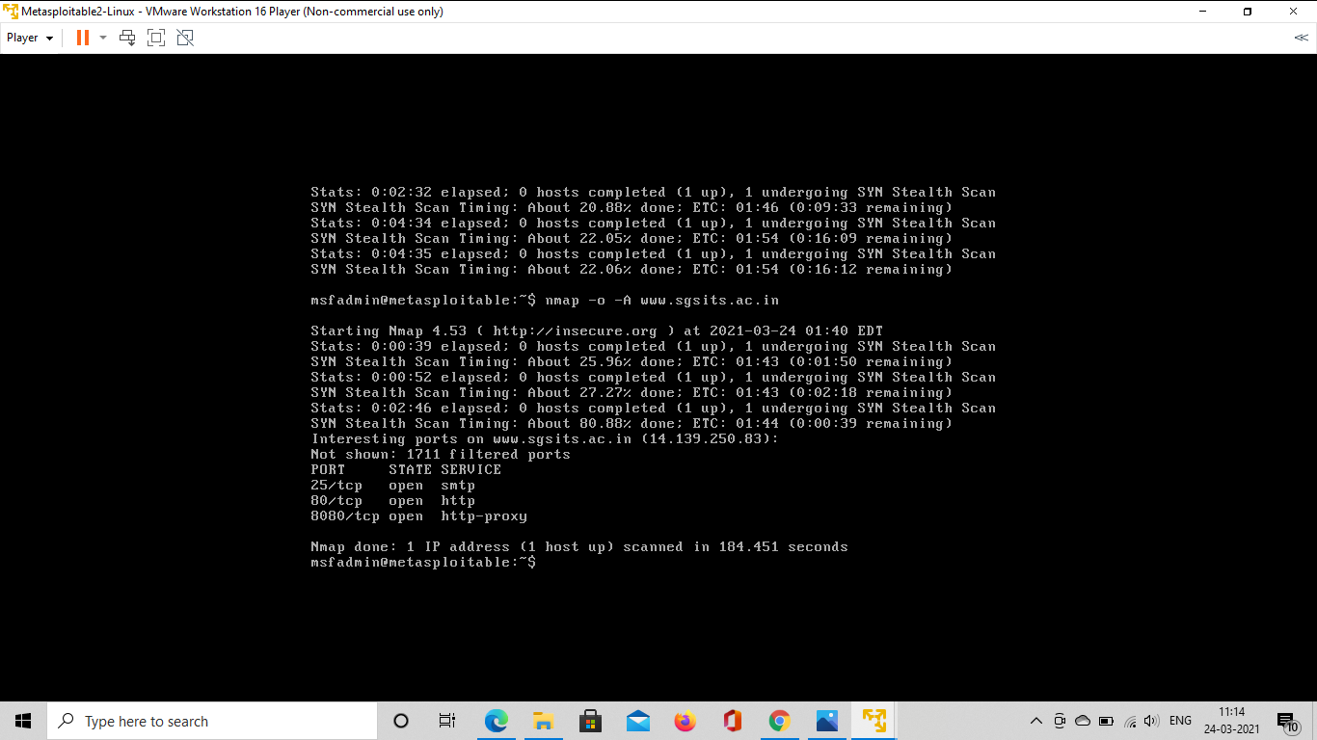

**VI. Execute the nmap in the given IP range and display the services running at specified ports i.e. port 80, 20, 21 etc. in that IP range.**

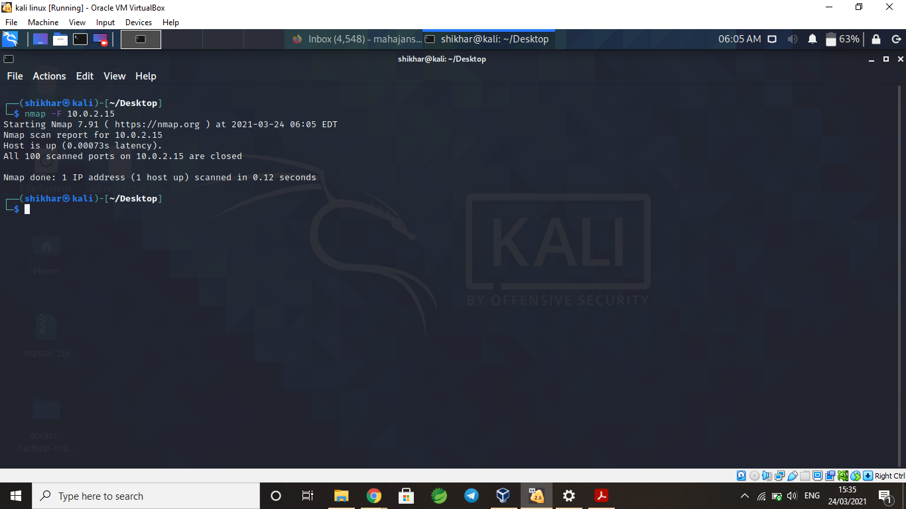

**Q8. Setup the Maltego application in Kali Linux and perform the following operations:**

**I. Select a target website/domain and perform the required transformation like email,**

**phone no, name etc. transformations. Generate the report for all the transformation.**

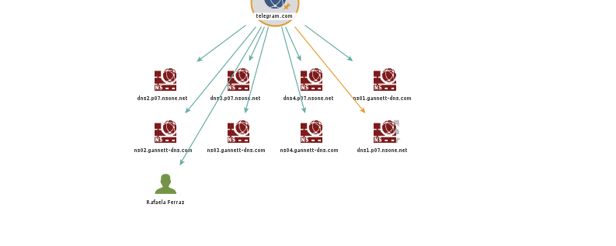

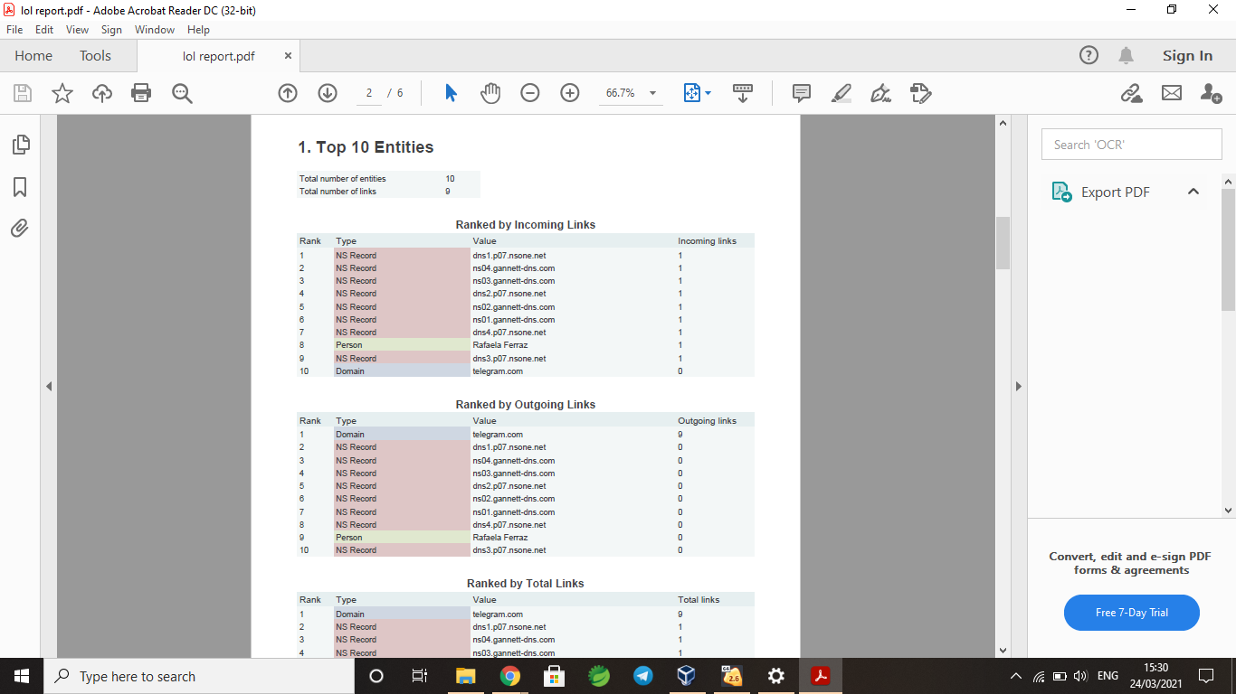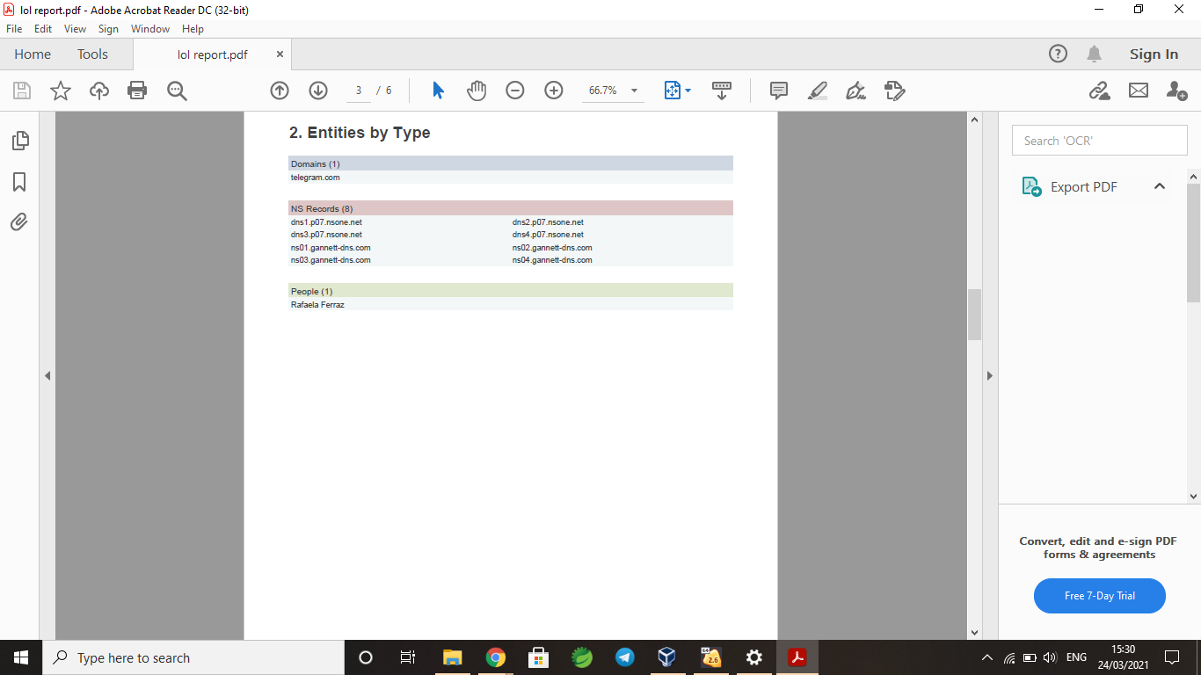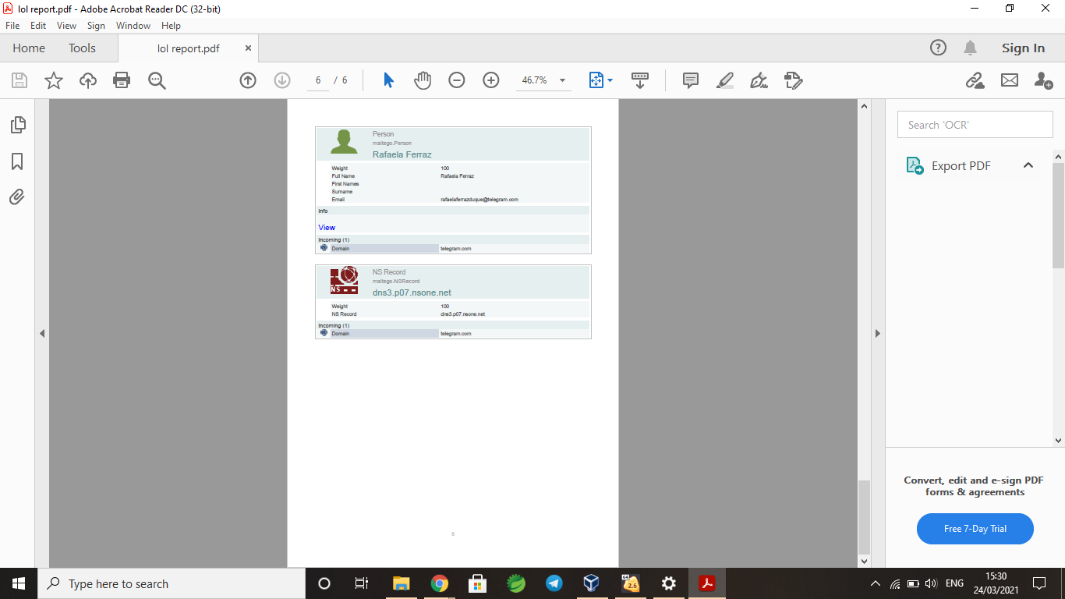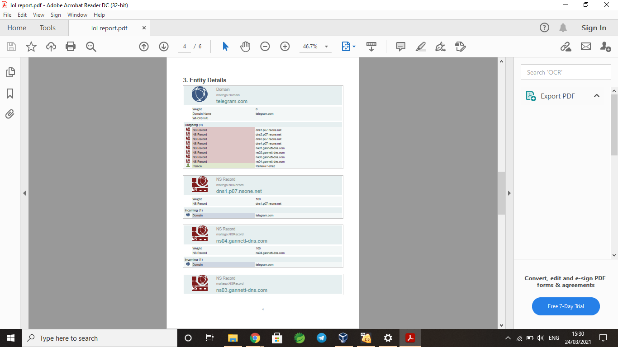

**III. List the name of any 5 general transformations which can be performed on a particular**

**target to get the required information.**

1.To DNS Name

2.[To EmailAddress [Bing]](https://docs.maltego.com/support/solutions/articles/15000019140-to-emailaddress-bing-)

3.[IPv4Address To Entities From WHOIS [IBM Watson]](https://docs.maltego.com/support/solutions/articles/15000024585-ipv4address-to-entities-from-whois-ibm-watson-)

4.[To IP Address [DNS]](https://docs.maltego.com/support/solutions/articles/15000019016-to-ip-address-dns-)

5.[To Domain [Find other TLDs]](https://docs.maltego.com/support/solutions/articles/15000019017-to-domain-find-other-tlds-)